User Interface

What is user interface?

The user interface (UI) is the point of human-computer interaction and communication in a device. This can include display screens, keyboard, a mouse and the appearance of a desktop. It is also the way through which a user interacts with an application or a website.

Types of UI’s

* Graphical User interface
* Command line interface
* Menu-driven user interface
* Voice user interface
* Form based user interface.

# Graphical user interface

A graphical user interface is a digital interface in which a user interacts with graphical components such as icons, buttons, and menus.

#Command line interface

It is a text-based user interface used to run programs, manage computer files and interact with computer for ex. Git bast.

#Menu-driven user interface

Menu driven interfaces is a type of user interface where users interact with a program or system through a series of menus or options. These menus present options or commands that the user can select.

# Voice user interface

A voice-user interface enables spoken human interaction with computers, using speech recognition to understand spoken commands and answer questions, and typically text to speech to play a reply. A voice command device is a device controlled with a voice user interface.

#Form-base user interface

A form-based interface uses textboxes, drop-down menus, text areas, check boxes, radio boxes and button to create an electronic from which a user completes in order to enter data into a system.

Benefits

1. UI design improves client acquisition.
2. UI design lowers costs and accelerate development.
3. UI improves customer retention.
4. UI designs helps increase productivity.
5. UI designs improves user interaction and experience.

Key points to prepare UI.

* Keep the interface simple.
* Create consistency and use common UI tags.
* Strategically use colour and texture.
* Make sure that the system communicates what’s happening.

Techniques used in UI.

* JavaScript
* React.js
* DOM (Document object model)
* BootStrap
* Mongodb
* JavaScript is a scripting language which is used to calculate, manipulate and validate the data, also can change the html and CSS.
* React.js is a JavaScript library also known as UI library,. React applications are usually built around a single HTML Element.
* The HTML DOM, when a web page is loaded, the browser creates the DOM (Document object model) of the page. The HTML DOM is constructed as a tree of object.

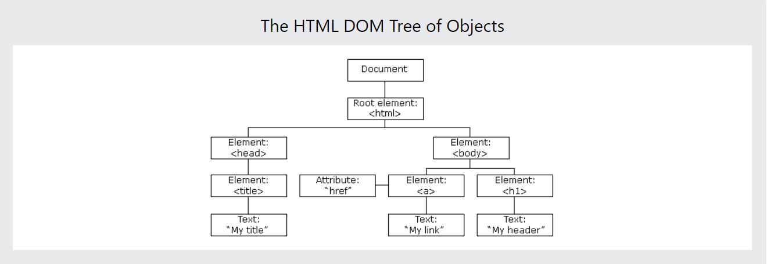

* Boot strap is a free and open-source CSS framework directed at responsive mobile-first-front-end web development it contains HTML, CSS, and Java Script based design templates for typography, forms, buttons etc.
* Mongodb is a source available cross platform document-oriented database program, Mongodb uses json-like documents with optional schemas.

{NOTE:- Our UI is under testing phase, therefore we are using json file format to perform CURD operation, after the successful testing the UI will be directly linked to mongodb from where UI can display as much data as available in google, or required as per the client request.}

Description of our project

Prepared a UI containing the filtered data in respect to the search result as per the requirement of the user or client.

In this UI we have used the “Instant food” as an example to render the data using the basic HTML elements, java script functions and React models.

Menu-driven UI is used to provide the sections and subsections in the UI i.e., multiple pages {page 1, page 2, etc.}

Each sections contains Subsections like organic, shopping results, inline product. And each subsections contains the further subsections which shows the responses or results individually.

The react model is getting all the data from the .Json file and we have prepared functions like filterData and showData to filter the data as per section or subsection and display the data using basic html elements.

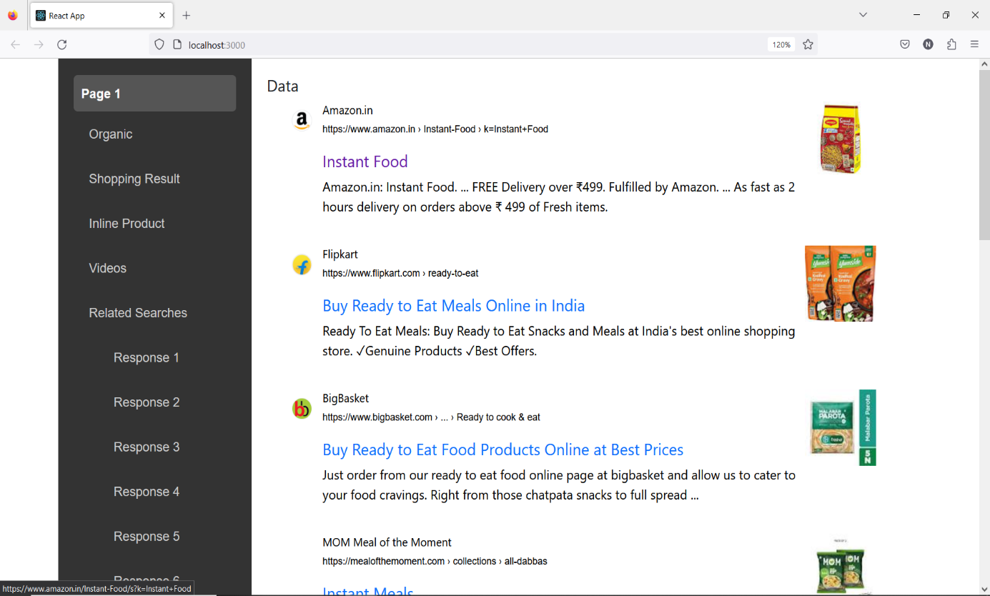

Objective behind the UI

* To help client in understanding the ranks of the ecommerce or brand sites that are selling specific product with better and filtered data.
* Separating the data into sub-section to provide better understanding of google results.
* Our UI scraps the data directly from google, and only provides the data that is relevant to the client and provide it in a format where client can get more insight regarding the product and sites that are selling it online along with other products and the ranking as per google.